

**Lab No. 12**

Mehran University of Engineering and Technology Shaheed Zulfiquar Ali Bhutto Campus, Khairpur Mir’s Department of Software Engineering

**Course: Operating System SW-225 (Practical) - Instructor: Engr. Shamshad Naveed**

**Objective: Introduction to shell scripting**

|  |  |  |  |  |
| --- | --- | --- | --- | --- |
| **Name:** | **Muhammad Saleem** | **Roll Number:** | | **K20SW033** |
| **Score:** | **Signature:** | **Date:** | **25-10-2022** | |

|  |  |  |  |  |  |  |  |
| --- | --- | --- | --- | --- | --- | --- | --- |
| **LAB PERFORMANCE INDICATOR** | SUBJECT KNOWLEDGE | DATA ANALYSIS AND INTERPRETATION | ABILITY TO CONDUCT EXPERIMENT | PRESENTATION | CALCULATION AND CODING | OBSERVATION  /RESULTS | SCORE |
|  |  |  |  |  |  |  |  |

**Task 01: What is Shell Scripting** ?

* A shell script is a computer program designed to be run by the Unix shell, a command- line interpreter.
* The various dialects of shell scripts are considered to be scripting languages.
* Typical operations performed by shell scripts include file manipulation, program execution, and printing text

# Advantages

The commands and syntax of the shell script are the same as that entered at the command line. Because of this, there is no need to switch to a completely different syntax.

* It is much faster to write a code in shell script than in other programming languages. This also means that the program is easier to create and files required can be selected easily.
* Shell script can also be used to provide linkage for already existing programs.
* Shell scripting can be used by users that are not experts to modify and tailor the behavior of their programs according to their requirements.

# Disadvantages

* There may be errors in shell scripting that prove to be quite costly.
* The programs in shell script are quite slow while executing and a new process is required for every shell command executed.
* Different platforms in shell scripting may also have compatibility problems.

# Shell Scripting Commands?

* **basename**
  + This command strips the directory and suffix from filenames. It prints the name of the file with all the leading directory components removed. It also removes a trailing suffix if it is specified.

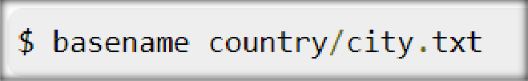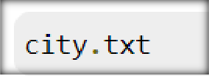

# cat

* + This command concatenates and prints the contents of the file. If there is no file, then it reads the standard input.

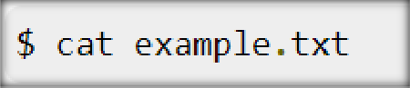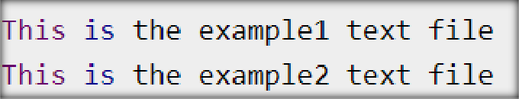

# cal

* This command is used to display a calendar. If a single parameter is specified, then the four-digit year is displayed. If there are two parameters, that denotes the month and the year. No parameter means that the current month is displayed.

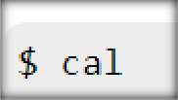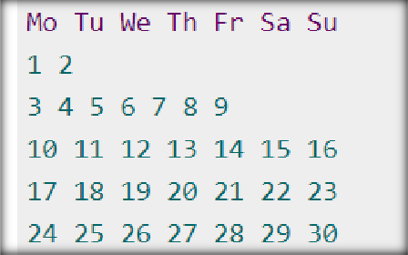

# cd

* cd is used to change the current working directory to the required folder. If the directory name is given, then the shell’s name is changed to that directory. Otherwise, it changes to home.

